Metabolic Activity Diffusion Imaging [MADI]:
I. Metabolic, Cytometric Modeling and Simulations

Charles S. Springer, Jr.,*^{a-e} Eric M. Baker,^{a†} Xin Li,^{a,c†} Brendan Moloney,^{a†} Gregory J. Wilson,^{f†}
Martin M. Pike,^{a,d} Thomas M. Barbara,ª William D. Rooney,^{a,d,g} Jeffrey H. Maki^{h}
†These authors, listed in alphabetical order, contributed equally.
ªOregon Health & Science University [OHSU] Advanced Imaging Research Center, ^{b}OHSU Knight Cancer Institute, ^{c}OHSU Brenden-Colson Center for Pancreatic Care, ^{d}OHSU Department of Biomedical Engineering, ^{e}OHSU Department of Chemical Physiology and Biochemistry, ^{f}University of Washington Department of Radiology [current: Bayer Healthcare, Radiology], ^{g}OHSU Department of Behavioral Neuroscience, ^{h}University of Colorado Anschutz Medical Center Department of Radiology.

*Corresponding author:
Charles S. Springer, Jr.
Advanced Imaging Research Center, L452
Oregon Health and Science University
3181 S.W. Sam Jackson Park Road
Portland, Oregon 97239
503-418-1531
springer@ohsu.edu

Supplementary Material

Supplementary Material [citations 1-85 in main text]:
S.I. Creating Digital Cell Ensembles: The Contracted Voronoi Cell. A standard Voronoi cell, $C_{i}$, is defined to be the volume comprising all points closer to the cell’s seed point, $c_{i}$, than to any other seed point:
$$\begin{aligned}C_{i}=\left\{x∈R^{3} | dist\left(x, c_{i}\right)<dist\left(x,c_{j}\right)\text{ for all} j≠i\right\}\#[S1]\end{aligned}$$
where $dist\left(x, y\right)$ denotes the Euclidean distance between points $x$ and $y$. Therefore, an ensemble of standard Voronoi cells fills all space (86). An elaboration is shown in Figure S1, which depicts a 2D analog of a cell ensemble [shaded], and four concentric cell domains [$Ω$, square boundaries], intracellular volume fraction, v_{i} = 1, and mean cell volume, V = 1/ρ [the cell number density reciprocal] for infinitely thin cell boundaries. Of course, the actual tessellation is three dimensional.
However, our diffusion simulations require [interstitial] space between the cells [Fig. 2 in text]. In this section, we describe how we “create” this space by contracting standard Voronoi cells. More elaborations of Fig. S1 are given below.
To produce a contracted Voronoi cell, we divide a standard cell into an inner shrunken cell, $C_{i}^{(cell)}$, and its’ enveloping annulus, $C_{i}^{\left(ann\right)}$. This division is accomplished by specifying an annulus width, $α_{i}$, by which the bounding planes of the standard Voronoi cell are translated towards the cell’s seed point. The contracted cell is the volume comprised of all points remaining internal to the translated planes:
$$\begin{aligned}C_{i}^{\left(cell\right)}=\left\{x∈R^{3} | dist\left(x, c_{i}\right)<dist\left(x,c_{j}+2α_{i}\frac{c_{i}-c_{j}}{dist\left(c_{i},c_{j}\right)}\right)\text{ for all} j≠i\right\}\#[S2]\end{aligned}$$
The portion of the original standard Voronoi cell not within the shrunken cell is taken to be the annulus:
$$\begin{aligned}C_{i}^{\left(ann\right)}=C_{i}∖C_{i}^{\left(cell\right)}\#[S3]\end{aligned}$$
[$C_{i}^{\left(ann\right)}$ represents all elements in $C_{i}$, but not also in $C_{i}^{\left(cell\right)}$]. In an ensemble of cells, the union of all annuli is taken in our simulations to be the fully connected ensemble interstitial [extracellular] space.
While each cell’s annulus width could be individually assigned, we implement contraction through specifying a single, global target annulus width, $α^{*}$. The annulus width is set to $α^{*}$ for all those cells for which that does not result in moving any of the bounding planes past the cell’s seed point. To prevent the latter

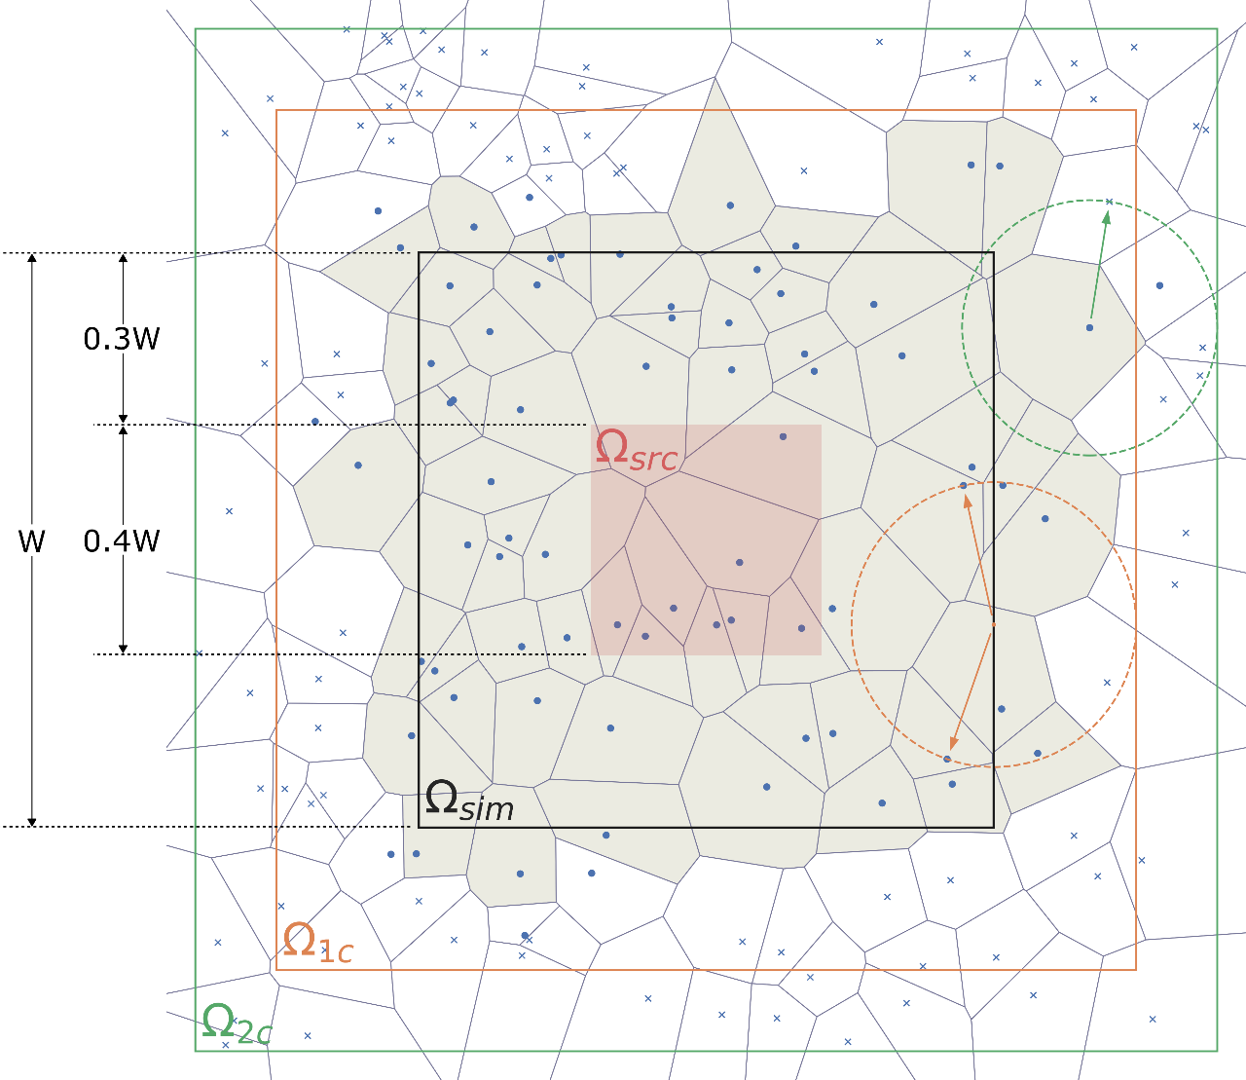
Figure S1. A 2D representation of standard Poisson-Voronoi tessellation, with punctile cell seeds. In this, the cells fill all space [intracellular volume fraction, v_{i} = 1; and mean cell volume, ⟨V⟩ = 1/ρ, the cell number density reciprocal]. Our random walk simulations, however, are conducted in 3D ensembles of contracted Voronoi cells [Fig. S2]. The shaded cells here represent an analog of a 3D ensemble. The four squares represent analogs of 3D domains discussed in detail in Section S.III. The dimension W is typically near 500 μm. Thus, the cubical domain Ω_{sim} typically has a volume (W³) near 125 μL. Such tissue volumes typically contain many thousands of cells [text]. Thus, it is important to note that [for clarity] the cells are not drawn to scale here.

scenario, we impose an upper limit, $α_{i}^{(lim)}$, on the annulus width of an individual cell: α_{i} must be the lesser of
$$\begin{aligned}α_{i}=\text{min}\left\{α^{*},{ α}_{i}^{\left(lim\right)}\right\}\#[S4]\end{aligned}$$
α* and α_{i}^{(limit)}. The value of this limit is a specified fraction, $κ∈[0,1)$, of the width that would result in a bounding plane moving past the cell’s seed point:
$$\begin{aligned}α_{i}^{\left(lim\right)}=\frac{1}{2}κ \text{min}\left\{ dist\left(c_{i},c_{j}\right) | \text{ for all} i≠j\right\}\#[S5]\end{aligned}$$
An example of a contracted Voronoi cell, $C_{5}^{(cell)}$, is illustrated in Figure S2. The grey dashed lines mark the boundaries of the original cells with adjacent standard Voronoi cells. The central pink area is $C_{5}^{(cell)}$, and the inner red dotted outline is the maximum extent to which $C_{5}^{(cell)}$ could be contracted based on the annulus limit, ${ α}_{5}^{\left(lim\right)}$, resulting from seed $c_{4}$ being the nearest neighboring seed to $c_{5}$. The sum of α₅ and α₄ is the interstitial “gap” between contracted cells 5 and 4. If α_{j} of a bordering cell $C_{j}$ is ${ α}_{j}^{\left(lim\right)}$, the gap at the j face of a cell can be different from the gaps at its other faces [not shown in Fig. S2].
S.II. Properties of the Stochastic Geometry: The Use of Single-Celled Ensembles. The randomness in contracted Voronoi cell geometries is driven by the underlying process governing the spatial dispersion of seed points. We have chosen the Poisson point process to effect this dispersion (86). Thus, all possible points in space have an equal, independent probability of being a seed point. Therefore, for a 3D domain
$Ω∈R^{3}$ with volume $V\left(Ω\right),$ the probability of finding $n$ seed points within $Ω$ is given by a Poisson distribution:
$$\begin{aligned}P\left(n\right)=\frac{{\left(ρ(V\left(Ω\right))\right)}^{n}}{n!}\exp\left(-ρ(V\left(Ω\right))\right) \text{for} n=0,1,…\#\left[S6\right]\end{aligned}$$
The coupling of the Poisson point process with standard Voronoi partitioning is known as Poisson-Voronoi tessellation, and is well-studied (86). To explore and characterize the properties of interest for our Poisson-contracted-Voronoi tessellation, 5x10⁶ independent, single-celled ensembles [i.e., $ρ=1$] with $κ=0.9$were generated. Picture the 3D version of only Fig. A2 $C_{5}$, with its annulus. The procedure described in (86) was followed to generate the initial uncontracted Voronoi cell of each single-celled ensemble. For the resulting single contracted cell of each ensemble, the surface area, A, and volume, V, were computed using the convex hull routines of the SciPy package (25,87), for each of 26 linearly-spaced $α^{*}$ values. Results

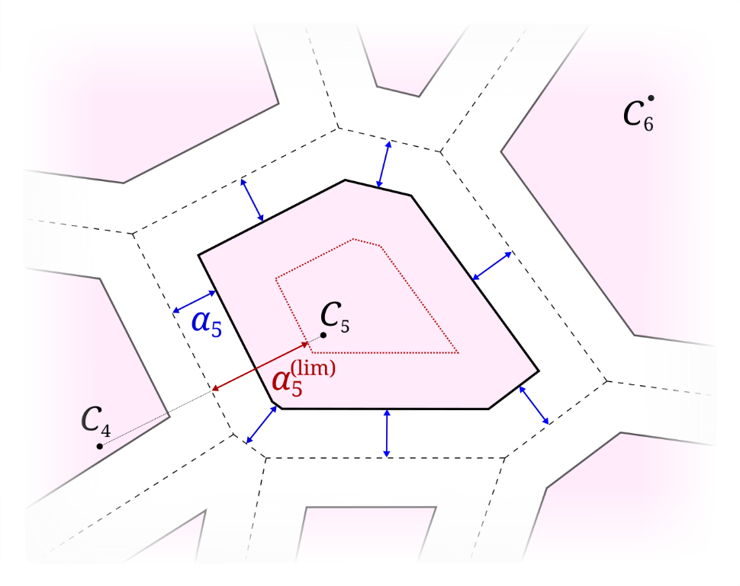
Figure S2. The scheme for contracting Voronoi cell C₅. The cell’s annular thickness relative to neighboring cell C₄ is denoted α₅. The process is described in detail in Sec. S.I. [α₅ + α₄] is the interstitial “gap” between cells C₅ and C₄.

derived from the five million cells are seen in Figures S3 to S7.
Figure S3a shows the dependence of the computed intracellular volume fraction, v_{i} (26 orange points), on the cell density-normalized target annulus width, $ρ^{1/3}α^{*}$, which is dimensionless. This relationship can be approximated with the empirical cubic polynomial expression in Equation [S7a] (blue curve).
$$\begin{aligned}v_{i}=\frac{\text{E}\left[\left.V\left(C_{j}^{\left(cell\right)}\right) \right|{ α}^{*}\right]}{\text{E}\left[\left.V\left(C_{j}^{\left(cell\right)}\right) \right| 0\right]}≈- 0.570444{\left(ρ^{1/3}α^{*}\right)}^{3}+10.6047{\left(ρ^{1/3}α^{*}\right)}^{2}-5.81457\left(ρ^{1/3}α^{*}\right)+1\#\left[S7a\right]\end{aligned}$$
The root-mean-squared error of the fitting is $2.13×{10}^{-5}$ and the maximum absolute error is $5.74×{10}^{-5}$. As expected, the v_{i} parameter clearly decreases with increasing annulus width.
For multi-celled ensembles, v_{i} = ρ⟨V⟩, and Eq. [S7a] can be re-written as Equation [S7b]. For fixed ρ,
$〈V〉 ≈ - 0.570444{\left(α^{*}\right)}^{3}+10.6047\left(ρ^{-1/3}\right){\left(α^{*}\right)}^{2}-5.8147{\left(ρ^{-1/3}\right)}^{2}\left(α^{*}\right)+ {\left(ρ^{-1/3}\right)}^{3}$ [S7b]
⟨V⟩ varies as a cubic expression in α*. Figure S3b shows the result for extension to pertinent multi-celled ensembles. It presents a family of such plots for different fixed ρ values. For these, the ordinate ⟨V⟩ and abscissa α* now have dimensions. For example, with ρ fixed at a typical tissue value of 5 x 10⁵ cells/μL (red), it is very clear ⟨V⟩ decreases from 2.0 to 0.7 pL as α* increases from 0 [v_{i} = 1] to 1.95 μm.
Alternatively, for fixed α* in Eq. S7b, ⟨V⟩ varies as a cubic expression in the reciprocal cube root of ρ (which has the dimension of length). In Figure S3c, a family of hyperbolae shows the ρ-dependences of ⟨V⟩ for different fixed α* values. One could select the ρ value desired for a contracted Voronoi cell domain, and then determine the α* value necessary to produce the ⟨V⟩ value desired. For this, Eq. [S7b] could be used for interpolation between the α* curves shown. Though the approach in Fig. S3b was originally conceived, Fig. S3c shows another way to understand the creation of domains with desired ρ and ⟨V⟩ values. It could allow a continuous ρ,⟨V⟩ parameter space.
Further illustrations of results from the individual studies of 5x10⁶ different single-celled ensembles are assembled in Figure S4. Panel a shows the probabilities of finding density-normalized cell volume, ρV($C_{}^{(cell)}$), values for different specified v_{i} values. For multi-cell ensembles, $v_{i}$ will also be a random variable with expectation $\text{E}\left[v_{i} | α^{*}\right]=ρE\left[\left.V\left(C_{j}^{\left(cell\right)}\right) \right| α^{*}\right]$. Extrapolating to the specific multi-cell ensemble

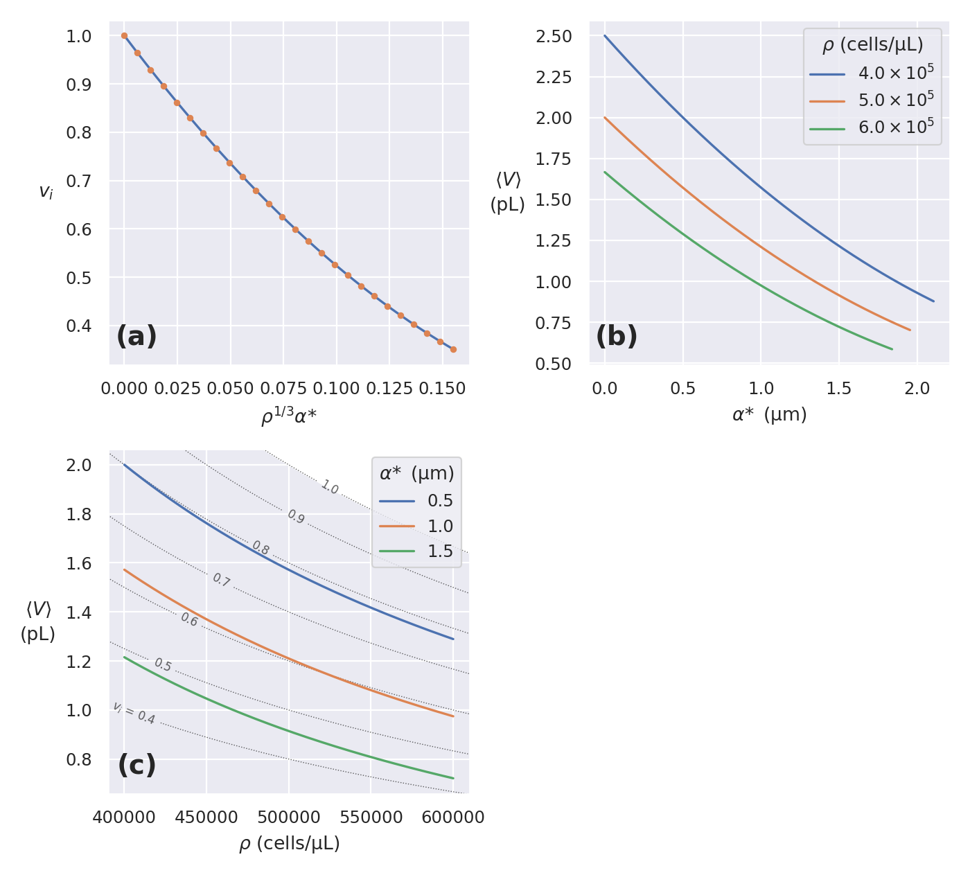
Figure S3. (a) The intracellular volume fraction, v_{i}, as a function of the cell density (ρ)-normalized global target cell annulus thickness (α*). Each of the 26 orange points is the v_{i} value averaged from analyses of 5x10⁶ single contracted Voronoi cells, with their annuli [imagine Fig. S2 cell C₅ in 3D.] Thus, this is the general case. The blue curve is from the fitting of cubic Eq. [S7a], with parameters given in Sec. S.II. (b) A family of specific cases [extended from (a)] for multicellular ensembles with three different values of fixed ρ, indicated by the colored iso-ρ contours. ⟨V⟩ decreases as α* increases from 0 [v_{i} = 1]. (c) A family of specific cases for multicellular ensembles with three different values of fixed α*, indicated by the colored iso-α* contours. Thus, ⟨V⟩ is plotted vs. ρ: a section of ρ⟨V⟩ parameter space. The colored curves are calculated from cubic Eq. [S7b]. ⟨V⟩ decreases with increasing ρ. Practical biological tissue values range from: 0.02 to 10 pL for ⟨V⟩ and 50,000 to 5,000,000 cells/μL for ρ. For further insight, hyperbolic iso-v_{i} contours are also plotted [darker gray]. No ρ⟨V⟩ combinations are allowed above ρ⟨V⟩ = v_{i} = 1.0

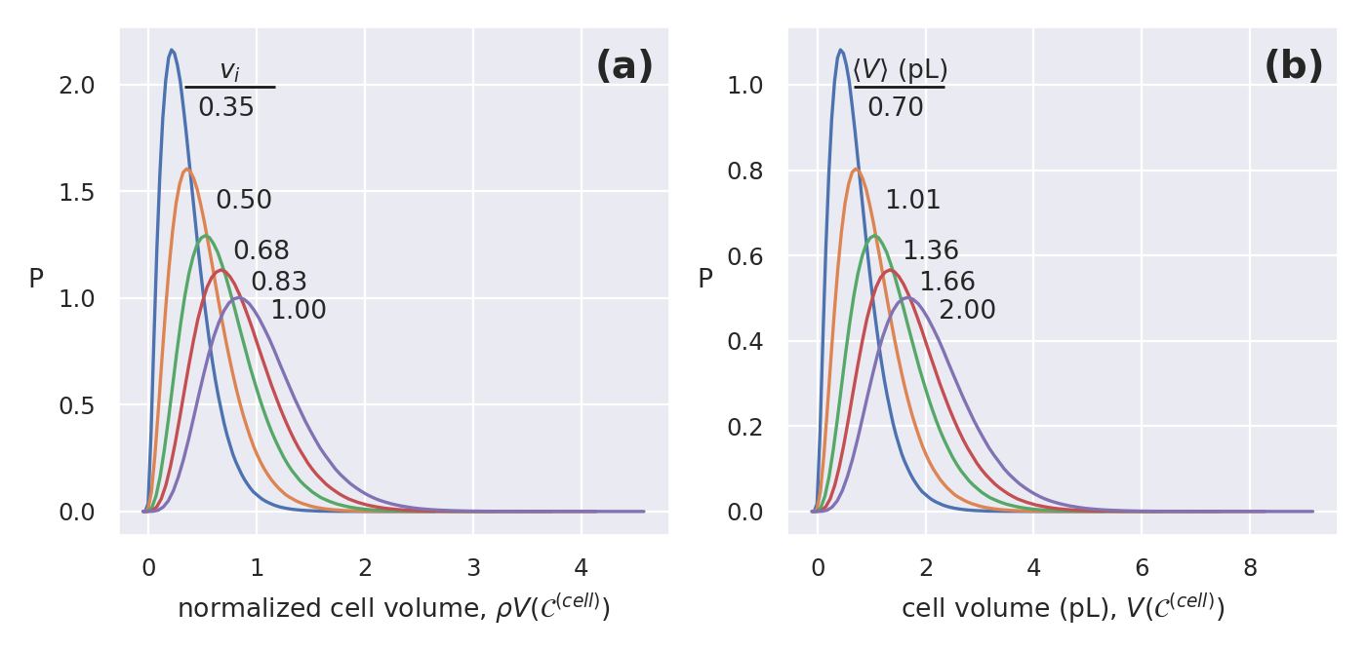
Figure S4. a) The probability density functions [P] of cell density-normalized cell volumes for 5x10⁶ single [i.e., ρ = 1] contracted Poisson-Voronoi cells. The individual curves are labeled with the desired global intracellular volume fraction (v_{i}) values for the distributions. For example, there is a distribution of V’s, each having v_{i} = 1. This is the general case. b) The specific case for ρ = 500,000 cells/μL [i.e., vs. ⟨V(C^{(cell)})⟩].

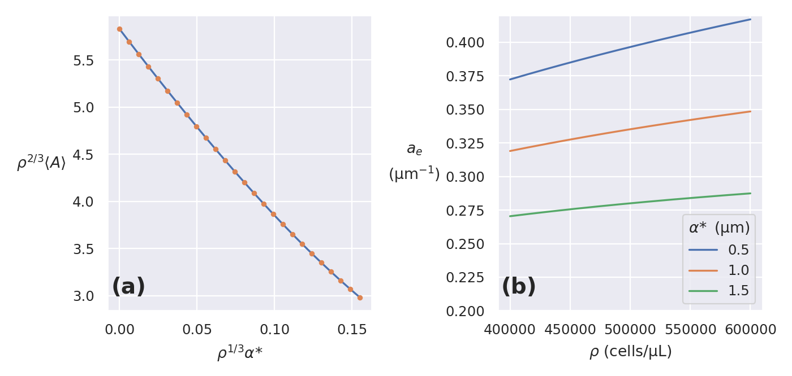
Figure S5. (a) The ρ-normalized cell area, ⟨A⟩, dependence on the ρ-normalized target annulus, α*. The orange points are averaged from 5x10⁶ single contracted Voronoi cells, with their annuli [imagine Fig. S2 cell C₅ in 3D.]. The blue curve is from fitting with parameters given in Sec. S.II. This is the general case. ⟨A⟩ decreases with increasing α*. (b) The ρ–dependences of the ⟨A⟩ρ product for specific multicellular ensembles at three different α* values. The ⟨A⟩ρ product is a_{e} [the cell surface area/ensemble volume]; a measure of the ensemble membrane “concentration.” It is analogous to v_{i}. We see a_{e} increases with increasing ρ.

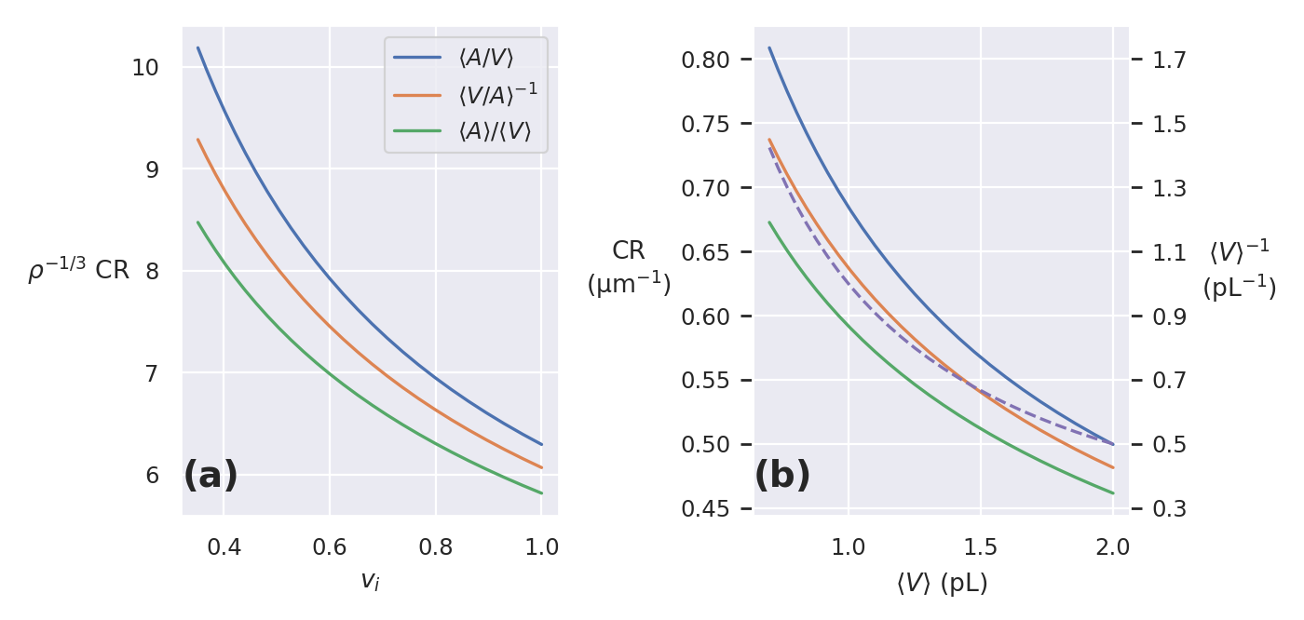
Figure S6. (a) The v_{i}-dependences of differently-averaged ρ-normalized cellular claustrophobia ratio (CR = A/V) values for 5x10⁶ contracted Voronoi cells. These are important for determining k_{io}, and are discussed in detail in Section S.IV. This is the general case. (b) The ⟨V⟩-dependences for the specific case of ρ = 500,000 cells/μL. In addition, the purple dashed curve shows the ⟨V⟩-dependence of 1/⟨V⟩, right ordinate.

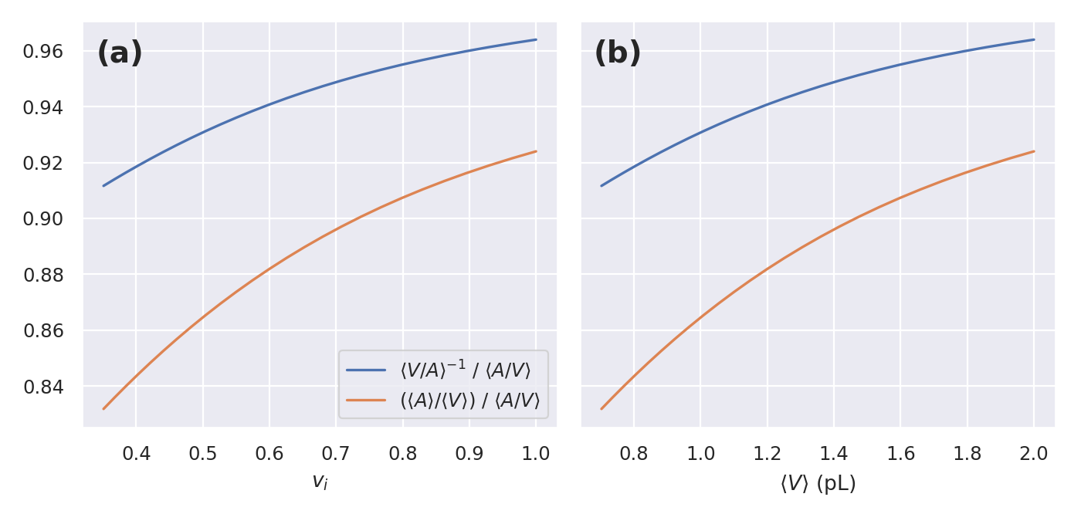
Figure S7. (a) The v_{i}-dependences of the ratios of differently averaged cellular claustrophobia ratio (A/V) values for 5x10⁶ contracted Voronoi cells. These are important for determining k_{io}, and are discussed in detail in Sec. S.IV. This is the general case. (b) The ⟨V⟩-dependences for the specific case of ρ = 500,000 cells/μL.] Note: the ratios are all close to unity.

case of ρ = 5x10⁵ cells/μL, Fig. S4b shows the probabilities for different desired ⟨V⟩ values. These resemble Γ distributions: ⟨V⟩ cannot be < 0.
Figure S5 is analogous to Fig. S3, except A replaces V in all instances. Thus, the ordinate of Fig. S5a is ρ^{2/3}⟨A⟩, and the abscissa is ρ^{1/3}α*. For Fig. S5b, the ordinate is a_{e}, defined as ρ⟨A⟩. This is the claustrophobia ratio, A($C_{j}^{(cell)})$/V($C_{j}^{(cell)})$, in single-celled ensemble $C_{j}^{(cell)}$ with α* = 0. The abscissa is ρ, and there is a family of curves for different α* values [analogous to Fig. S3c]. a_{e} can be thought of as representing the ensemble surface “concentration.” It increases with ρ. Along with the permeation permeability, p_{p}, this is what our simulation’s success suggests is the major impediment to water diffusion in tissue.

S.III. Creation of Contracted Voronoi Cell Ensembles for Desired ρ and V values. The simulation domain, $Ω_{sim}$, is a cube with edges of length $W$ (Fig. S1, for standard Voronoi). If a molecule exits $Ω_{sim}$ at any point during a walk, the simulation immediately ceases, reporting an error. All molecular walks originate in the inner cubical [source] domain, $Ω_{src}$, with edges of length $0.4W$ (Fig. S1, for standard Voronoi).
The specific value of $W$ we use is determined with the Equation [S8] heuristic
$$\begin{aligned}W=\text{max}\left\{10L_{RW} , \text{min}\left\{20L_{RW} ,\sqrt[3]{\frac{\left(8×{10}^{5}\right)}{ρ}}\right\} \right\}\#\left[S8\right]\end{aligned}$$
where:
$$\begin{aligned}L_{RW}=\sqrt{2D_{0}t_{RW}}\#\left[S9\right]\end{aligned}$$
is the diffusion trajectory length over the temporal extent of the random walk. [Note: this is not the same as the net diffusion displacement, d^{ms} = 6D₀t_{RW} (Fig. 3).] A typical W value is 438 μm. Use of this heuristic has been found to sufficiently eliminate cases of molecules leaving $Ω_{sim}$, while also satisfactorily reducing the computation time by allowing $Ω_{sim}$ domains with sufficiently curtailed numbers of cells. A (438 μm)³ tissue domain has a volume, $V\left(Ω_{sim}\right)=$ 84 nL [0.084 μL], and contains many thousands of cells [see text and Fig. 1]. Thus, for clarity, the cells in Fig. S1 are not drawn to scale.
A single cell ensemble created to tessellate $Ω_{sim}$ is a random realization of the contracting Poisson-Voronoi process. It should be emphasized that any particular multicell ensemble generated for a desired $ρ$ and $〈V〉$ does not necessarily have an amount of cell seeds equal to the expected [desired] number, $\text{E}\left[n|ρ,Ω_{sim}\right]=ρV\left(Ω_{sim}\right),$or the desired mean cell volume $〈V〉$. Ensemble cells protruding from Ω_{sim} faces, many of their seeds, and major portions of their volumes, are therefore not counted in Ω_{sim}. Stated in another manner, $ρ$ and $〈V〉$ values derived from a collection of cell ensemble realizations will be equal to those specified in the limit of an infinite collection. Equally, a cell ensemble will have the specified $ρ$ and $〈V〉$ values in the limit of $[V\left(Ω_{sim}\right)]→∞$. However, because the Ω_{sim} domain contains many thousands of cells, the percentage ρ and ⟨V⟩ uncertainties are very small.
The specified$ρ$ and $〈V〉$ values are the desired quantities for a Poisson-contracted Voronoi ensemble. But, we can find the more directly-implementable parameter $α^{*}$ that corresponds to these $ρ$ and $〈V〉$ values by solving Eqs. [S7] with $v_{i}=ρ〈V〉$. There will be at most three unique $α^{*}$ solutions but only one in the range of $α^{*}$ values desired. This is due to Eq. [S7a] being a bijection (as can be seen in Fig. S3a) over the range in question. Every realization with the same specified $ρ$ and $〈V〉$ will use the same $α^{*}$, but the application of $α^{*}$ (Eq. [S4]) does not happen until after a random standard Voronoi realization for a desired set of cell seeds has been generated (Fig. S1).
Valid tessellation of $Ω_{sim}$ with contracted Voronoi cells necessitates that a larger, encompassing domain, $Ω_{pop}⊃Ω_{sim}$, be populated by a set of seed points, $Φ$, satisfying the Poisson point process for desired $ρ$. Cells with seed points outside $Ω_{sim}$ can have portions that protrude into $Ω_{sim}$. Accounting for this possibility requires that, for every point on the $Ω_{sim}$ boundary ($∂Ω_{sim}$) there is a point in the collection of seed points within $Ω_{pop}$ that is closer to it than to any point outside of $Ω_{pop}$:
Ωpop⊇x∈R3 Φ ∃ x'∈∂Ωsimabdistx, x'<distci,x' ∀ ci∈Φ∩Ωsim#S10
The nature of contracted Voronoi cells – with annuli - imposes an additional requirement. The limit on the annulus width depends on the distance between the cell’s seed point and the nearest-neighboring seed point. Ensuring that all cells within or protruding into $Ω_{sim}$ have an unbiased annulus width leads to the requirement that, for these cells, no point outside $Ω_{pop}$ can be closer to the cell’s seed point than the nearest neighboring seed point within Ω_{pop}:
Ωpop⊇x∈R3 ∃ ci∈Φabdistx, ci<distci,cj ∀ cj∈Φ∖{ci}#S11
where $\hat{Φ}$ is the subset of seeds for those cells inside or overlapping $Ω_{sim}$:
$$\begin{aligned}\hat{Φ}=\left\{c_{i}∈Φ | { C}_{i}∩Ω_{sim}≠∅\right\}\#\left[S12\right]\end{aligned}$$
Figure S1 illustrates these concepts in 2D with standard Poisson-Voronoi tessellation. The red square represents $Ω_{src}$, the black square $Ω_{sim}$. The shaded cells are all those within or protruding from the $Ω_{sim}$ boundary. The blue dots and “x”s are cell seeds: the former represent the seed set influencing partitioning within $Ω_{sim}$. These comprise seeds of either the shaded cells or the shaded cells’ nearest neighbors.
The orange and green squares are formulated under the constraint that $Ω_{pop}$ be a square concentric with $Ω_{sim}$. The region enclosed by the orange square is labeled $Ω_{1c}$ [i.e., pop = 1c], and is the minimal $Ω_{pop}$ necessary to satisfy Eq. [S10] when only the seed points within $Ω_{sim}$ are known. The orange dashed circle marks the case that defines the extent of the orange square. The center and radius of the circle are, respectively, the point on $∂Ω_{sim}$ farthest from a seed within $Ω_{sim}$ and the distance to that seed.
The region enclosed by the green square labeled $Ω_{2c}$ [i.e., pop = 2c] is the minimal $Ω_{pop}$ necessary to satisfy Eq. [S11] when only the seed points within $Ω_{1c}$ are known. $Ω_{2c}$ must enclose all circular regions within which a point would be closer to a cell seed, of those seeds for cells that are within or overlap $Ω_{sim}$, than to the nearest neighboring seed in $Ω_{1c}$. Of these circular areas, the green dashed circle is the one that enlarges $Ω_{2c}$ to its maximum extent.

S.IV. Specifying k_{io} for a Random Walk in a Given Ensemble. As detailed in the text, Eq. [5] is crucial for the MADI approach. It shows that to specify the average $k_{io}$ for a random walk, ⟨k_{io}⟩, in a given ensemble, one needs the permeation probability, p_{p}, and the ensemble-averaged claustrophobia ratio, $〈A/V〉$. As with the desired $ρ$ and $〈V〉$ values for a realized cell ensemble, $〈A/V〉$ is taken as that of the governing contracted Poisson-Voronoi generating process. Thus, it is not necessarily the ⟨A/V⟩ in Ω_{sim}, where the walking will occur. Thus, much like the determination of v_{i} for $α^{*}$ above, the value for $〈A/V〉$ is interpolated from those determined for the five million single, contracted Voronoi cell ensembles. For the 26 α* values, we compute $〈A/V〉\left(α^{*}\right)= \left(1/{5,000,000}\right)\sum_{i=1}^{5,000,000}{\left[{A_{i}\left(α^{*}\right)}/{V_{i}\left(α^{*}\right)}\right]}$. From the 26 ⟨A/V⟩ values we interpolate that for an ensemble with our desired v_{i} value.
Figure S6a shows the v_{i}-dependence of the cell density-weighted $〈A/V〉$ so determined [blue curve] on the intracellular volume fraction, $v_{i}$. The plot of the ratio of the averages, ⟨A⟩/⟨V⟩, is also shown [green curve]. It is very important to note that $〈A/V〉≠〈A〉/〈V〉$. ⟨A/V⟩ is appropriate for determination of ⟨k_{io}⟩ for random walks with a given p_{p} in a given ensemble. The harmonic mean, ⟨V/A⟩⁻¹, would be appropriate for the reciprocal of the mean intracellular water molecule lifetime ⟨τ_{i}⟩⁻¹. The harmonic mean plot is also shown [red curve] in Fig. S6a. The lifetime τ_{i} was reported for many early trans-cytolemmal water exchange studies, with the caveat that ⟨k_{io}⟩ ≠ 1/⟨τ_{i}⟩ (6). Figure S6b shows the ⟨V⟩-dependences of three means for the specific tissue case of ρ = 5 x 10⁵ cells/μL. Now, ⟨A/V⟩ must have units. The claustrophobia ratio ⟨A/V⟩ is seen to fall from 0.80 to 0.50 μm⁻¹ as ⟨V⟩ increases from 0.75 to 2.00 pL. We previously discussed the A/V decrease with increasing V in general qualitative terms (4).] We also show the ⟨V⟩⁻¹ decrease is similar.
The v_{i}-dependences of the ratios ⟨V/A⟩⁻¹/⟨A/V⟩ and (⟨A⟩/⟨V⟩)/⟨A/V⟩ are shown as the blue and orange curves, respectively, in Figure S7a. It is important to note the different means are not too dissimilar under biological conditions. ⟨A⟩/⟨V⟩ is reduced from ⟨A/V⟩ by at most by 15%, and then only at v_{i} values unreasonably small for most tissues. The ⟨V⟩-dependences of these ratios are shown in Fig. S7b for the specific tissue case of ρ = 5 x 10⁵ cells/μL.

S.IV.a. Determining a molecule’s position and compartmental environment within an ensemble.
The procedure used for simulating a random walk (Fig. 2) requires knowing within which compartment (i.e., which $C_{i}^{\left(cell\right)}$ or $C_{i}^{\left(ann\right)}$) a molecule is currently located, and in which compartment it will be at the end of the subsequent time step. This does not depend on what lies along the path between the positions at two successive time steps. The compartmental information is obtained by querying a kD-tree for the two nearest cell seeds, $c_{1}$ and $c_{2}$, and their distances, $dist\left(x,c_{1}\right)≤dist(x,c_{2})$, to the position, $x$, of the molecule. See Figure S8. [When α_{i} is computed before each simulation, only the coordinates of seeds like those represented by the Fig. S1 blue dots are needed. During simulation, the seeds of only the Fig. S1 shaded cells are required.] By definition (Eq. [S1]), $x∈C_{1}$. The $C_{1}$ sub-compartment in which $x$ is located is determined by
$$\begin{aligned}x∈\left\{\begin{matrix}C_{1}^{\left(cell\right)}, & \text{if} α^{'}≥α_{1} \\ C_{1}^{\left(ann\right)}, & \text{otherwise}\end{matrix}\right. \#\left[S13\right]\end{aligned}$$
where α′ is the perpendicular distance to the boundary plane separating the interstitial annuli of the two cells
$$\begin{aligned}α^{'}=\frac{dist{\left(x,c_{2}\right)}^{2}-dist{\left(x,c_{1}\right)}^{2}}{2 dist\left(c_{1},c_{2}\right)}\#\left[S14\right]\end{aligned}$$
with seeds nearest the molecule: A diagram of the geometric foundation of Eq. [S13] and Eq. [S14] is presented in Fig. S8.

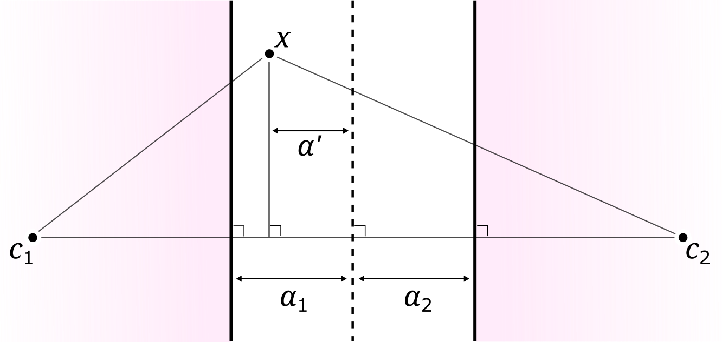
Figure S8. A geometric perspective of how the spatial position of a walking molecule at position $x$ is indexed relative to the seeds of adjacent contracted Voronoi cells [c₁, c₂]. At the instant pictured, the molecule is in the interstitial [extracellular] gap between cells C₁ and C₂ [in the C₁ annulus]. See Sec. S.IV.b.1.

S.IV.b. Simulation of a random walk. Figure S9 presents the logic described below in the form of a flowchart.
S.IV.b.1. Location in space. A molecule walk starts at random location $x_{k=0}$ within domain $Ω_{src}$. A potential position, $x_{k+½}$, for the molecule at the next time step is drawn from a three-dimensional normal distribution having mean, $x_{k}$, and component variance, $2D_{0}t_{s}$. As given in the text, the mean separation of x_{k} and x_{k+1/2} is (12D₀t_{s}/π)^{1/2} [the median separation is (12D₀t_{s})^{1/2}erf⁻¹(1/2)]. The specific compartment of this potential position is determined (Eq. [S13]).
If x_{k+1/2} is inside a cell while x_{k} is in that cell’s gaps, or if x_{k+1/2} is in a gap while x_{k} is inside a bordering cell, the molecule will have to cross one membrane [m = 1] in traversing between the two positions. If x_{k} is inside a cell while x_{k+1/2} is inside an adjacent cell, the molecule will have to cross two membranes [m = 2] in traversing between the two positions. If neither of these two conditions is true, the molecule either stays in the extracellular space or stays inside the same cell. The number of membrane crossings for this case is zero [m = 0].
A random number between 0 and 1 is drawn to determine whether the molecule will successfully permeate the membranes required to get to x_{k+1/2}. If the random number is between p_{p}^{m} and 0, the molecule successfully crosses the membranes, and the molecule’s position set to x_{k+1/2}. If not successful, the molecule’s position at the next time step remains at x_{k}. The molecule is not allowed angular reflections off the cell boundary.
A practical example of this is the situation for water molecules within the neuronal myelin sheath, where there are many cell membranes [m is large] in close series (1). Although there is reasonably rapid exchange of water in and out of the sheath, the probability on any one molecule completely traversing the entire sheath is very small: p_{p}^{m} decreases exponentially with m.
S.IV.b.2. Location in time. After each time step, the elapsed time is then advanced. When the elapsed time reaches t_{RW,max} [80 ms, here], the random walk is concluded. If not, the sampling of the potential position begins again for the next time step.

Figure S9. A flow chart for the simulation of a molecular random walk through an ensemble of contracted Voronoi cells. See Sec. S.IV.b. for a discussion.

S.VI. Interpreting the SDE Decay.
Though there are analytical [i.e., equation-based] methods for fitting experimental SDE decays, these are all empirical: the parameters cannot be assigned as actual physical properties that might be independently assayed. Furthermore, one or two parameter expressions are insufficient. Gaussian diffusion can be characterized with one parameter, the apparent diffusion coefficient [ADC], in the equation: ln[S(b)/S₀] = e^{-b(ADC)}. However, Gaussian behavior does not obtain for almost any biological tissue (8). The diffusion kurtosis expressions have two parameters; D_{ap} and K_{ap} (8).
There have been many demonstrations that three parameter empirical expressions are sufficient to describe experimental SDE decays (23). Perhaps the most popular is the general bi-exponential Eq. [10], re-written here as Equation [S15], where p_{A} is the mole fraction [“population”] of molecules exhibiting
${S\left(b\right)}/{S_{0}} = p_{A}e^{-bD_{A}}+ \left(1- p_{A}\right)e^{-bD_{B}}$ [S15]
diffusion coefficient D_{A}, and all other molecules exhibit D_{B}. This expression has three variable parameters: p_{A}, D_{A}, and D_{B} [p_{B} = 1 – p_{A}], which are taken as time-independent. Equation [S15] implicitly assumes there is no molecular exchange between the populations [i.e., k_{AB} = 0], which is almost never the case. More importantly however, every realistic tissue diffusion goes through an essentially infinite number of D values during the diffusion time, t_{D} [= t_{RW}; Figs. 3b,3d,3e,3f]. The significant hazards of inappropriate empirical bi-exponential interpretations are quite perilous (81). Attempts to assign physical quantities to p_{A}, D_{A}, and D_{B} can lead to very serious errors (2,17): these are empirical parameters.

S.VII. Kärger/Andrasko Model and its’ Descendants.
The Kärger/Andrasko [KA] Model [reviewed in (17)] was introduced starting in the 1960’s to add the potential for steady-state trans-cytolemmal molecular exchange by altering the empirical bi-exponential expression, Eqs. [10] and [S15] with a two-site-exchange [2SX] formalism. We do not use KA in the MADI approach [for reasons given below]. However, since it has been employed in almost all DWI models incorporating exchange (88), and its’ concepts are heuristic, we give a brief recapitulation. Equations [10] and [S15] are re written more explicitly [in MADI notation] in Equation [S16], where p_{i}′, D′_{i}, p_{o}′, and D′_{o} are
[S16]
$$S/{S_{0}}= p_{i}^{}e^{-bD_{i}^{}}+ p_{o}^{}e^{-bD_{o}^{}}= p_{i}^{}e^{-q^{2}D_{i}^{}t_{D}} + p_{o}^{}e^{-q^{2}D_{o}^{}t_{D}}= p_{i}^{}e^{-q^{2}D_{i}^{}t_{D}}+ p_{o}^{}e^{-q^{2}D_{o}^{}t_{D}}$$

the apparent intra- and extracellular water mole fractions and diffusion coefficients [i.e., as affected by exchange]. These are expanded in terms of the intrinsic quantities [sans exchange] in the Bloch-McConnell-Woessner [BMW] Equations [S17-S20] (2). The matrix bases for these integrated
$$q^{2}D_{i}^{}= \frac{1}{2}\left[q^{2}D_{i}+ q^{2}D_{o}+k\right]- \frac{1}{2}{\left\{{\left[arg\left({}_{Dio}\right)+ k_{io}- k_{oi}\right]}^{2}+4k_{io}k_{oi}\right\}}^{1/{2 }} [S17]$$
$$q^{2}D_{o}^{}= \frac{1}{2}\left[q^{2}D_{i}+ q^{2}D_{o}+k\right]+ \frac{1}{2}{\left\{{\left[arg\left({}_{Dio}\right)+ k_{io}- k_{oi}\right]}^{2}+4k_{io}k_{oi}\right\}}^{1/{2 }} \left[S18\right]$$
$$p_{i}^{}= \frac{1}{2}+ \frac{1}{2}\left\{\frac{arg\left({}_{Dio}\right)\left[p_{o}- p_{i}\right]+k}{{\left\{{\left[arg\left({}_{Dio}\right)+ \left(k_{io}- k_{oi}\right)\right]}^{2}+4k_{io}k_{oi}\right\}}^{1/2}}\right\} [S19]$$
$$p_{o}^{}= \frac{1}{2}- \frac{1}{2}\left\{\frac{arg\left({}_{Dio}\right)\left[p_{o}- p_{i}\right]+k}{{\left\{{\left[arg\left({}_{Dio}\right)+ \left(k_{io}- k_{oi}\right)\right]}^{2}+4k_{io}k_{oi}\right\}}^{1/2}}\right\} [S20]$$
differential expressions, as well as the case including the blood water population [3S2X], are given in (22). In these 2SX equations: p′_{i} = 1 – p′_{o} = [(ρV)′ + f_{M}]/[1 – f_{M}], p_{i} = 1 – p_{o} = [(ρV) + f_{M}]/[1 – f_{M}], k_{oi} = [p_{i}/(1 - p_{i})]k_{io}, κ_{Dio} ≡ q²|D_{i} – D_{o}|, and arg(κ_{Dio}) ≡ q²(D_{i} – D_{o}). The quantities (ρV)′, κ_{Dio}, and arg(κ_{Dio}) are, respectively, the apparent ρV product [v_{i}′], the diffusigraphic shutter-speed (17), and its’ argument. The volume fraction of intracellular macromolecules, f_{M} (2,9,22), is usually fixed at 0.2 (9): it is assumed extracellular macromolecules do not significantly displace tissue aqueous solutes. We immediately see the KA model – like all s-s approaches - cannot separate the ρV product. This is a significant shortcoming.
As originally conceived, the KA model postulated constant single-valued, intrinsic diffusion coefficients for intra- and extracellular water molecules [D_{i} and D_{o}: D_{in} and D_{out} in Fig. 3] in the absence of exchange: i.e., these would be time-independent. However, the Fig. 3b simulations suggest this is not the case. Until the well-mixed water condition is achieved [~20 ms in Fig. 3b], D_{o}, and particularly D_{i}, vary considerably. Almost instantly, D_{o} limits at some value determined mostly by ρ and V, and D_{i} eventually limits at zero. If there were closed-form non-empirical expressions describing these time-dependences, they could be incorporated into Eqs. [S16-S20]. But, alas, there are none. If we could use data from only t_{D} values sufficiently large to render the un-mixed water period insignificant, there would be only three unknowns: k_{io}, D_{o}, and ρV. But, this is not the case for t_{D} values commonly employed. As we show in the text, t_{D}(well-mixed) could be even greater than 20 ms (80).
We could take recourse in the shutter-speed laws (2). Thus, in the vanished s-s condition, Vs-sL [κ_{Dio} = 0; formerly FXL], D′ = p_{i}D_{i} + p_{o}D_{o} [Gaussian diffusion]. However, Vs-sL obtains at only t_{RW} [t_{D}] = 0 and the D_{i}/D_{o} cross-over at t_{v} [~5 ms in Fig. 3b]. For any general case, we can’t know the cross-over D and t_{v} values. Besides, we have three unknowns, p_{i}, D_{i}, and D_{o}. As indicated in the text, arg(κ_{Dio}) changes sign as the system passes through the cross-over Vs-sL. In some scenarios, this is significant (2). For the small s-s regime, Ss-sR [κ_{Dio} < k (≡ k_{io} + k_{oi}); formerly FXR] and large s-s regime, Ls-sR [κ_{Dio} > k; formerly SXR] conditions, we must employ the complete model Eqs. [S16-S20]. But, the last paragraph shows this is not possible.
The large s-s limit, Ls-sL [κ_{Dio} >> k; formerly SXL] condition, however, is qualitatively different. This is particularly manifest in the SDE-CG decay (17).
We note the b axis has different significance for the SDE-CG and [more common] -CT acquisitions. For CT, b represents q² while for CG, it represents t_{D}, Eq. [S16]. In the CT decay, the trans-cytolemmal water exchange condition continually changes: varying exchange condition [VXC]. However, in the CG plot, the exchange condition is invariant for the entire decay: constant exchange condition [CXC]. The only way to change the condition is to change the wave number: q² plays the CA role. For CA s-s studies, VXC plot analogs are shown in (2,5,10), and CXC plot analogs in (4,7).
In the initial period, the CT and CG decays are identical (8,17). At some b value, however, they diverge, and the CG decay becomes articulated: it appears more bi-exponential (8,16,17,48,49). [By definition, the Ls-sR condition obtains when the temporal decay [CG] is detectably bi-exponential (2).]
When the system is actually in the Ls-sL condition, q²D′_{o} = q²D_{o} + k_{oi}, and q²D′_{i} = q²D_{i} + k_{io} (2). We have no analytical expression for D_{o}. But, we have seen once t_{D} > t_{WM}, D_{i} limits at zero [Fig. 3b]. Thus, q²D′_{i} = k_{io}. If t_{D} is sufficient that all ¹H₂O_{o} coherence has de-phased, the decay is linear [in the semilog plot], and k_{io} is directly determined from the negative of the slope. The decay has gone through a non-linear/linear [non-Gaussian/pseudo-Gaussian] switchover. The ρV product value is not obtained, let alone separated.
This approach has been used in a CG study of gel-suspended isolated glioma cells (16). As is the case for such samples, the situation is particularly favorable, p_{i} ≈ 0.05 (16) and thus k_{oi} is very small. This method has been attempted for anesthetized rat brain in vivo [discussed in (8)]. However, it is not clear that the Ls-sL condition can be achieved for in vivo human brain CG acquisitions.
Another popular related DWI method for mapping trans-membrane water exchange is filter exchange imaging [FEXI] (89-92). However, FEXI measures only the apparent exchange rate [AXR], which is not a rate, and which confounds k_{io} with ρ, V, and f_{M} (1). This is because FEXI is a form of what physical chemists term a “chemical relaxation” approach. As such, it can determine only k [≡ k_{io} + k_{oi}, in the present context]. By itself, it cannot separate k_{io} from k_{oi}: V and ρ must be determined independently of k_{io} to access x^{c}MR_{NKA}, Eq. [1]. Furthermore, FEXI analysis almost always assumes two constant, single-valued D quantities, which must differ considerably: FEXI analyses usually assume D_{o} >> D_{i}. The invalidity of these assumptions was shown in this work. In fact, at t_{D} < t_{v}, D_{o} < D_{i} [Figs. 3b and 3e]. FEXI gives unrealistically small k_{io} values for brain gray and white matter (8). This may be because the crucial FEXI chemical relaxation period often begins near t_{v}, when D_{i} and D_{o} have identical magnitudes (Figs. 3b,3e).

S.VIII. References found in only SM.

- Tanemura M. Statistical distributions of Poisson Voronoi cells in two and three dimensions. FORMA 2003;18:221-247.
- Barber CB, Dobkin DP, Huhdanpaa HT. The Quickhull algorithm for convex hulls. ACM Trans. Math. Soft. 1996;22:469-483.
- Olesen JL, Østergaard L, Shemesh N, Jespersen SN. Diffusion time dependence, power law scaling, and exchange in gray matter. NeuroImage 2022;251:118976.
- Lampinen B, Szczepankeiwicz F, van Westen D, Englund E, Sundgen PC, Latt J, Stahlberg F, Nilsson M. Optimun experimental design for filter exchange imaging: Apparent exchange rate measurements in the healthy brain and in intercranial tumors. Magn. Reson. Med. 2017;77:1104-1114.
- Åslund I, Nowacka A, Nilsson M, Topgaard D. Filter-exchange PGSE NMR determination of cell membrane permeability. J. Magn. Reson. 2009;200:291-295.
- Bai R, Li Z, Sun C, Hsu Y-C, Liang H, Basser PJ. Feasibility of filter-exchange imaging (FEXI) in measuring different exchange processes in human brain. NeuroImage 2020;219:117039.
- Khateri M, Reisert M, Sierra A, Tohka J, Kiselev VG. What does FEXI measure? arXiv 2022;2202,00496v1. [ doi.org/10.48550/arXiv.2202.00496 ]

